CENWP-OD-B 11 August 2024

MEMORANDUM FOR THE RECORD

SUBJECT: 24BON042 MFR WA Shore AWS RB1 Pacific Lamprey Mortality

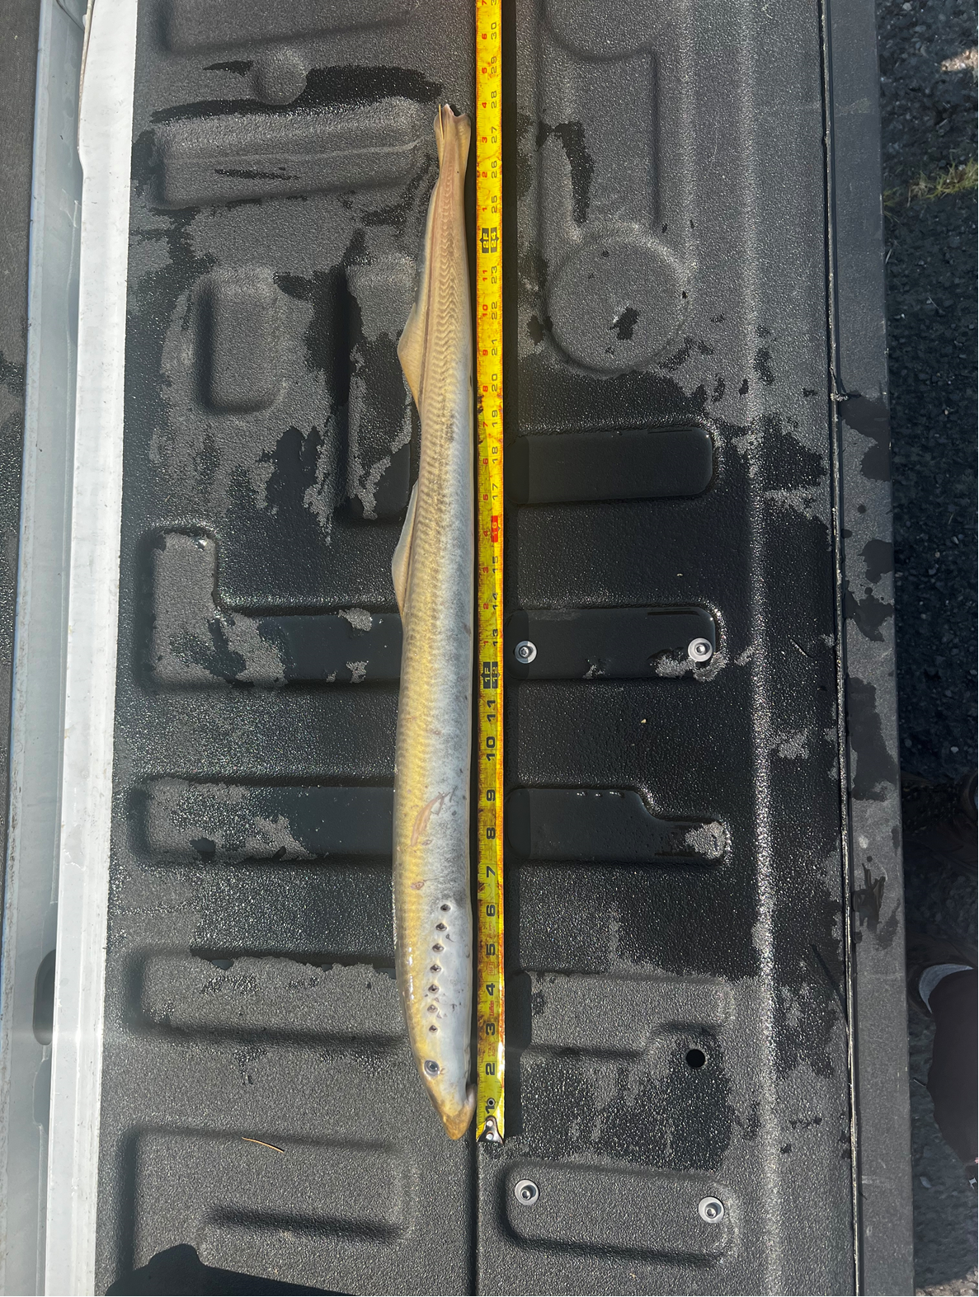
On the morning of 10 August 2024, Project Biologists discovered one adult Pacific Lamprey mortality in Rest Box 1 of the Washington Shore Auxiliary Water Supply LPS (WA Shore AWS LPS RB1). The fish was measured, scanned for PIT tags, inspected, and returned to the river.

- Species – Pacific Lamprey (Entosphenus tridentatus)
- Origin – Unknown
- Length – 71.12cm
- Marks and tags – None
- Marks and Injuries found on carcass – None.
- Cause and Time of Death – Unknown
- Future and Preventative Measures – N/A

Sincerely,
Bonneville Project Fisheries

